**Overview**

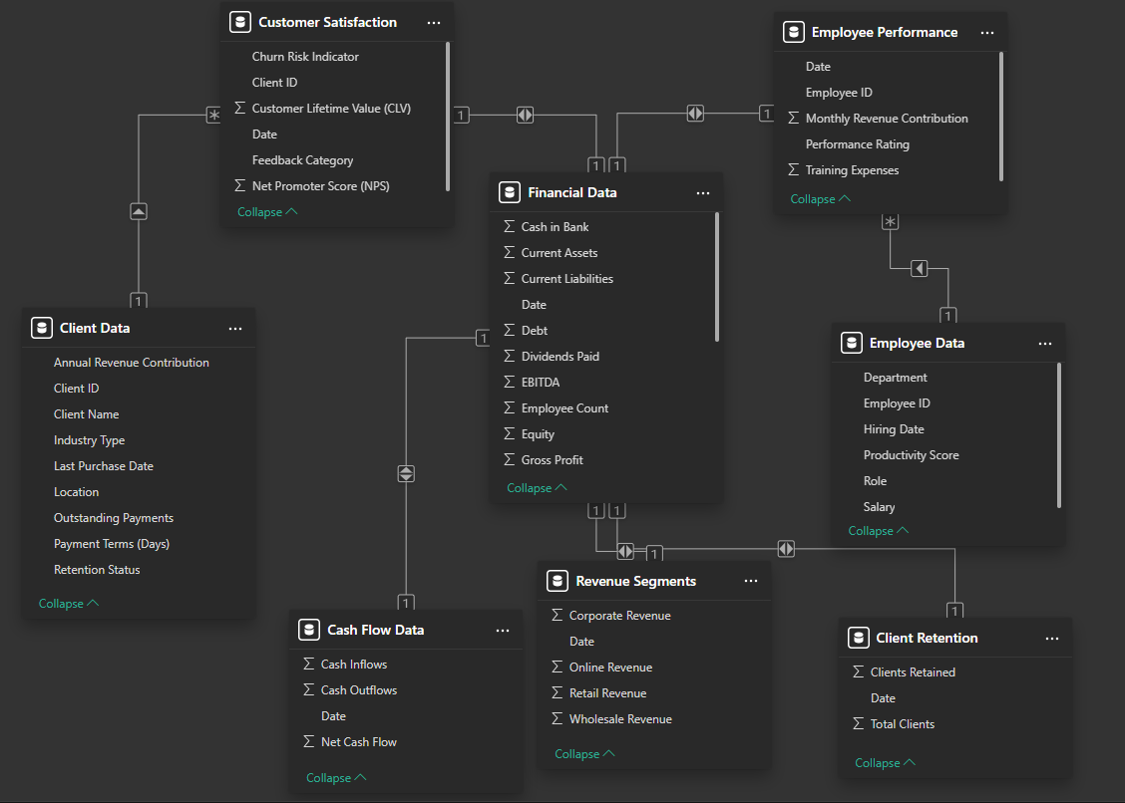In this project, I will analyze the company's financial data to help track its profit, revenue, and expenses over time and evaluate cash flow trends. I will examine revenue by region to identify which regions are performing well and which are not. Additionally, I will assess employee performance to determine which employees deserve investment in their talents. Furthermore, I will analyze customer churn and identify whether high-value customers are leaving. This will help draw the company's attention to retaining these valuable customers.